**One Step to Disabled People using OpenCV Object Recognition**

**Name: Aakash Jayprakash Nigam**

Department of information technology, K.C. College, Vidyasagar Principal K.M. Kundnani Chowk,

D.W. Road, Churchgate, Mumbai 400020, India

**Abstract**

As the name of the title is “One Step to Disabled People using OpenCV object recognition” in this project we are trying to help disabled challenged people to interact with surrounding with the help of object recognition. As the serve of “WHO” tells more than 1.3 billion people are challenged by [blindness and visual impairment](https://www.who.int/news-room/fact-sheets/detail/blindness-and-visual-impairment) and 200 million people have an intellectual disability (IQ below 75). While this project will try to help this people to interact and identify the surrounding.

**Keywords:** Disabled person, OpenCV, NumPy, Cascade file, gtts, Database, etc

**Introduction**

As per research of WHO (“[World Health Organization](https://www.who.int/disabilities/world_report/2011/report.pdf)”) in 2019 more than 2 billion people are disabled, which is 37.5% of total population. Where 1.3 billion people are affected by some form of [blindness and visual impairment](https://www.who.int/news-room/fact-sheets/detail/blindness-and-visual-impairment). This represents 17% of the world’s population and about 200 million people have an intellectual disability (IQ below 75). This represents 2.6% of the world’s population.

In the above case how this project (one step to disabled people using OpenCV Object Detection) will help?

1. As the number of blindness and visual impairment is high there are not able to communicate with anyone, may the person be known or unknown. This project will help to communicate with anyone who is known or unknow to the disable person with the help of Machine Learning and Artificial General Intelligence, OpenCV, gtts, and datasets.
2. It also helps to intellectual disability who can’t low I.Q. in day to day life.
3. This can create a new dataset for faces by adding to current dataset and so on.

**Discussion/Working**

Activity 1

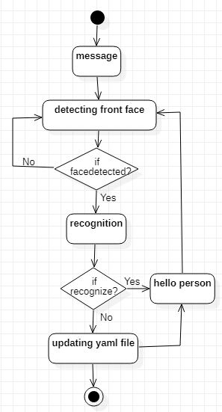

1. **Detecting face**

In this step program try to detect all possible face’s in front of camera or in frame.

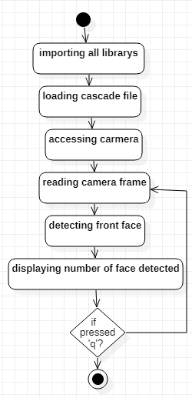

1. **Recognition face**

If theface is detected in the above step then it recognizes the face if the face is recognizing then it sends a message to the user using earphone to ears.

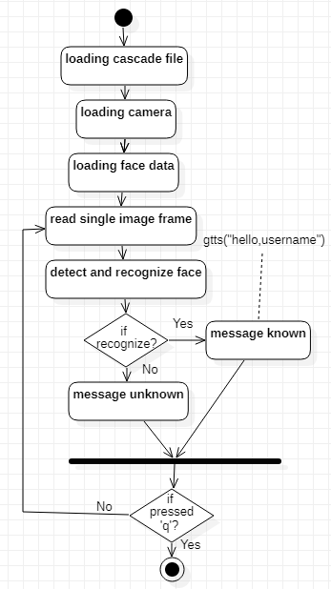

1. **Updating face data set**

As we seen the above two steps if the person is in the dataset then the person will be recognized else it will not. Then user will not be able to interact with the surrounding. For this below two steps will help to update the new face in the dataset.

1. **Capturing front face**

This step will help to capture new front face to dataset which will feather will be converted into an array set of the data.

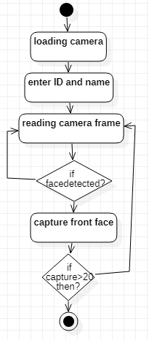

Front face is converted into grey format to detect easily in any light.

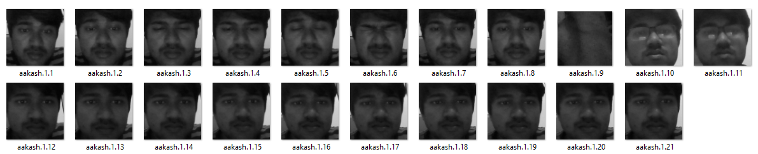

1. **Converting front face to yaml file**

As the new front face of the person will be capture then it will be converted into numerical array to recognize the face using yaml file.

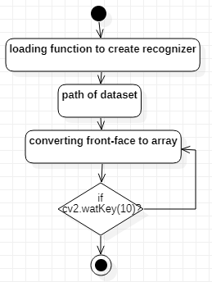

The yaml dataset

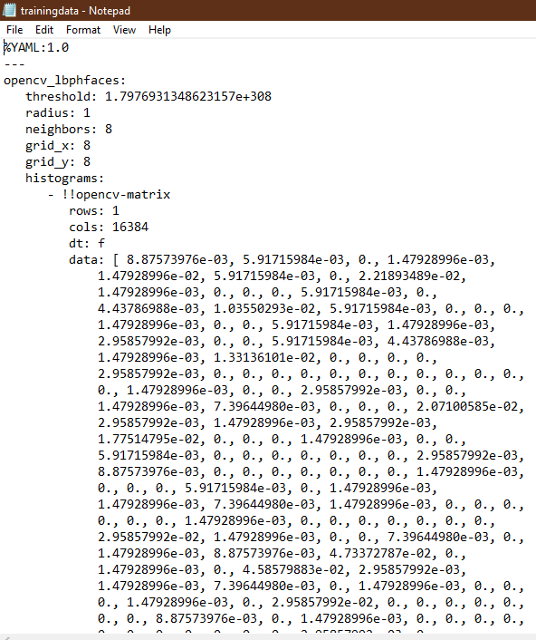

1. **Result**

The person in front of the camera or in frame will be compared with the dataset if the person is recognized successfully than it will send message to ear using earphone.

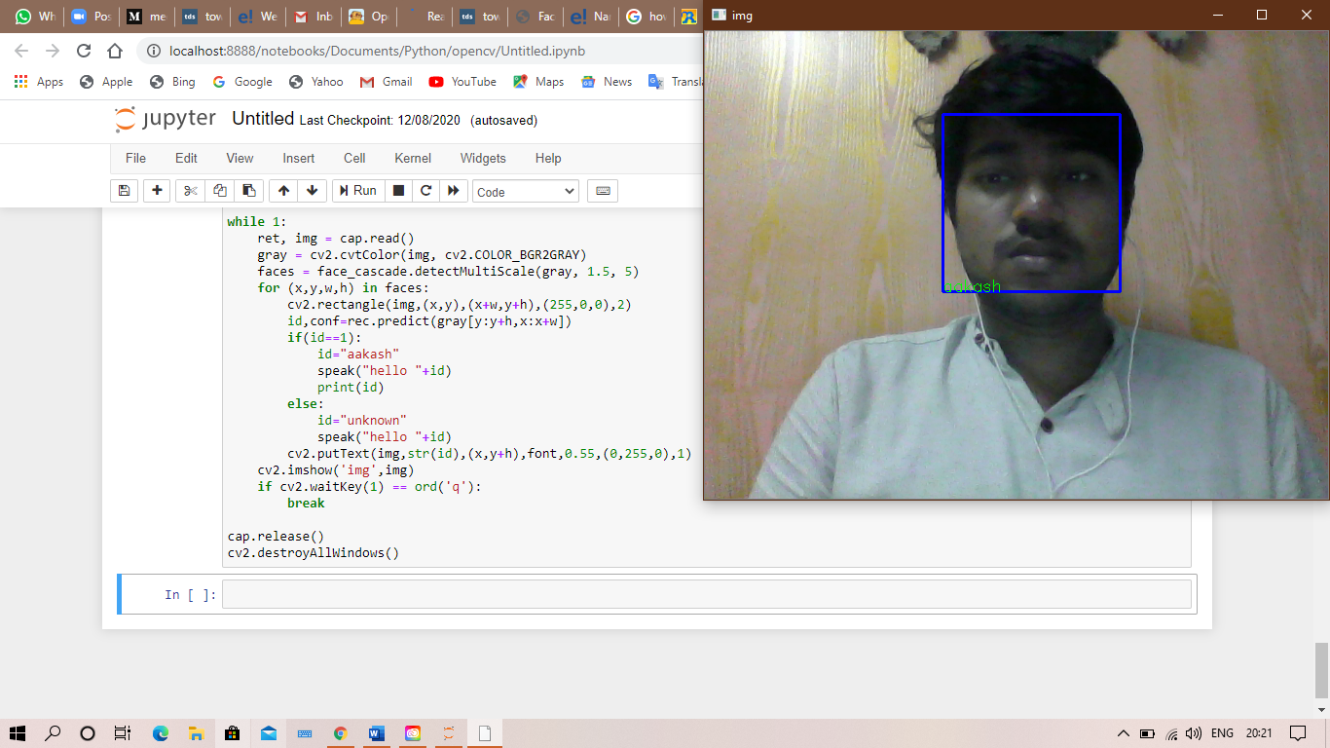

**Future study**

1. OCR (“Optical Character Recognition”) which is use for recognition of characters which can help blind person for reading book, shop name so on.
2. A* pathfinding algorithm can be implemented in OpenCV for directing the way for walking without using any stick.

**Conclusion**

In this paper, we have explained all the feature of “one step to disabled person using OpenCV object detection. This program can also be used as IOT project. It has multiple features like detecting, recognition and updating of dataset. As the conclusion of the project is aimed to interact with surrounding and helping disabled person by providing general solution.

**References**

1. <https://www.inclusivecitymaker.com/disabled-people-in-the-world-in-2019-facts-and-figures/#:~:text=Business-,Disabled%20People%20in%20the%20World%20in%202019%3A%20facts%20and%20figures,37.5%25%20of%20the%20world's%20population.>
2. <http://www.ijitee.org/wp-content/uploads/papers/v9i6/F3789049620.pdf>
3. <https://docs.opencv.org/master/d1/de5/classcv_1_1CascadeClassifier.html>
4. <https://realpython.com/face-detection-in-python-using-a-webcam/>
5. <https://realpython.com/python-speech-recognition/>